# Answers to the Questions

[Section by Cullen Fahey]

# Question 1

## What difference(s) did you notice between the 2-period time plots of the pure tone at 440 Hz, the tone with harmonics added at equal amplitudes and the tone with harmonics at decreasing amplitudes?

The 2-period time plots of the pure tone differ with an added harmonic doesn’t sound natural or fluid. The Tone with the added harmonics is softer sounding than the pure tone and is shown in the graph as well. The tone with harmonics at decreasing amplitudes sounds the most natural and fluid of the three due to the harmonics decreasing.

## What is the mathematical expression for the exponential decaying note in Part 1?

Sin (2*pi*F*T) * e^(-t/τ)

Correct according to Payton

## 

## Describe how the sound of the clar_melody differed from the first project due to the added harmonics.

The added harmonics created a softer more natural sound because it creates a more natural decay of the tone instead of a uniform decay creating a better audio affect.  
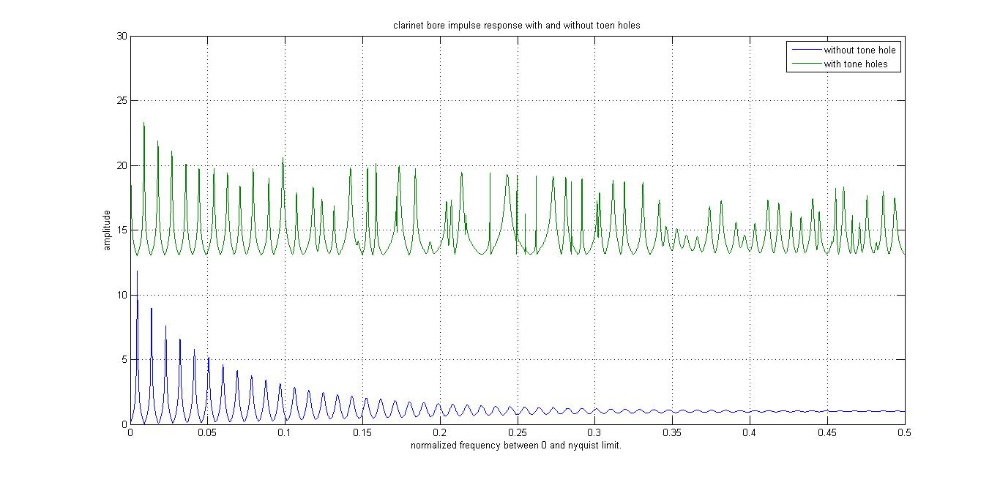

Figure shows what a natural decay looks like compared to a uniform decay

**This figure should go in the report because it shows what a signal does when it decays with harmonics and without. Notice how the note still decays with harmonics but it has a more natural look to it.**

## 

## 4. What other modifications can you think of that might make a melody sound more natural?

Some additional modifications that could be done to make the melody sound more natural are to lengthen, shorten, or remove the pauses after the notes. Other methods include adding contours or echoing the notes.